Final Report

Name: Sergio Gonzalez
Course / Cohort: Project 114, Cohort 65
Assignment: Final Report
GitHub Repository Link:

Evidence of Functionality
Frontend/UI
Attach 3 screenshots only:
- Main screen
- One interaction working
- One validation / error state

Backend/Logic
- Screenshot of one key component/element (route / controller / service)
Retrospective
1.Which part of the project was the most difficult or challenging for you, and why?
The first session—introduction was easy because it was more straight forward and easy.
2. The sessions with the stack data structure were more challenging because of the pointers and nodes involved.
(Explain what you did to overcome it or what could have helped you handle it better.)
2. What did you enjoy the most or learn the most from while working on this project, and why?
I learned more about the nested for-loops in the final assignment of this project. Therefore, that was the aha moment for me.
(Describe how this project contributed to your learning or skill development.)
This project helped to think more logically at various levels when writing code and analyzing it.
AI Disclosure (Required) – Highlight the one that applies
- I did not use AI
- I used AI for help
- AI generated parts of my code (if it’s the case, provide an explanation of the code in your own words).

Python Anagram Checker Function (using the sort( ) method:
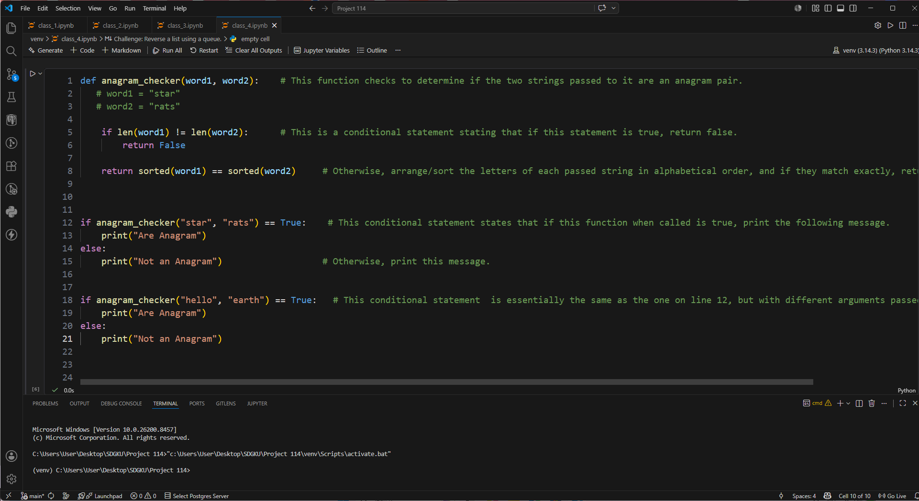
Python Alternative Anagram Checker Function (without the sort( ) method):

